***ABSTRACT***

Project name: Employee Customized Task Management System

This project offers a comprehensive overview of the fundamental ideas of database management systems. In the creation of this project, I was able to develop a database system in order to assist any companies willing to use it in managing data flow as effectively as possible in order to meet future objectives. By using this database system, all the companies will be able to swiftly distinguish, maintain and develop all main departments, achieving the company's goals of increasing efficiency and proficiency in the management of employees. The goal of this project is to provide a good database with a simple front end that the user can easily understand. In order to fully develop and work on the project, some tools had to be used to make the process more efficient. The usage of GANTT charts, diagrams to illustrate and visualize the way the database functions. Furthermore to create the database, the ideas are translated to SQL, a database computer language designed for the retrieval and management of data in a database.   
Finally, at the end of the project, I will have completely understood and included the relational schema, ER diagram, and management queries, all of which will are crucial in the functioning and aid in future development of the system.

***INTRODUCTION***

A customized task management system is an intrinsic need in almost any existing or aspiring successful business. Effective distribution and management of work is important in any area of life, especially in businesses. Seeing as companies are growing larger and larger by the day, miscommunication is a common occurrence and mishaps often happen on a day-to-day basis. A simple understandable system that can be understood by anyone working in the company can only improve work life and increase efficiency. This project offers a solution to all businesses that need to manage their employees and tasks dynamically. Often in workplaces containing a lot of employees, it can be confusing to know who is working on a project and who is available to work on something new. Instead of having managers hassle with keeping track of all mundane tasks that need to be done, this system automates that work and displays any specific information that is needed to be displayed. Not only that, employees among each other avoid confusion regarding working on a task or the progress of it.

***The purpose of the project is:***

* To learn how to keep properly create and try manage the database of Customized Task Management, a system that stores data and enables functionality that organizes and maintains the management of any tasks within a company
* Aid any businesses in effective and efficient task management for their workforce.

***Goals for this project:***

* Make an effective database system for any companies
* Have it be intuitive and easy to use
* Have any immediate changes done in the program to be applied immediately without delay to the database records.
* Help ease in work organization
* Understand how to create and maintain a database management system

***Business Description***

Employee Customized Task Management System is a service-based business located in Tirana. It has recently started its activity and aims to work with all big companies that look to use its services. The services offered include an intuitive interface where the user can manage their own tasks / other’s tasks. The “customized” in the name means that every company can create their own specific set of tasks for their system. All employees can check their own tasks and check all the features available to them for that specific task. In order for the system to work, the users, tasks and how they interact with each other need to be kept track of.

Below is the GANTT Chart where the time taken to develop the project is seen.

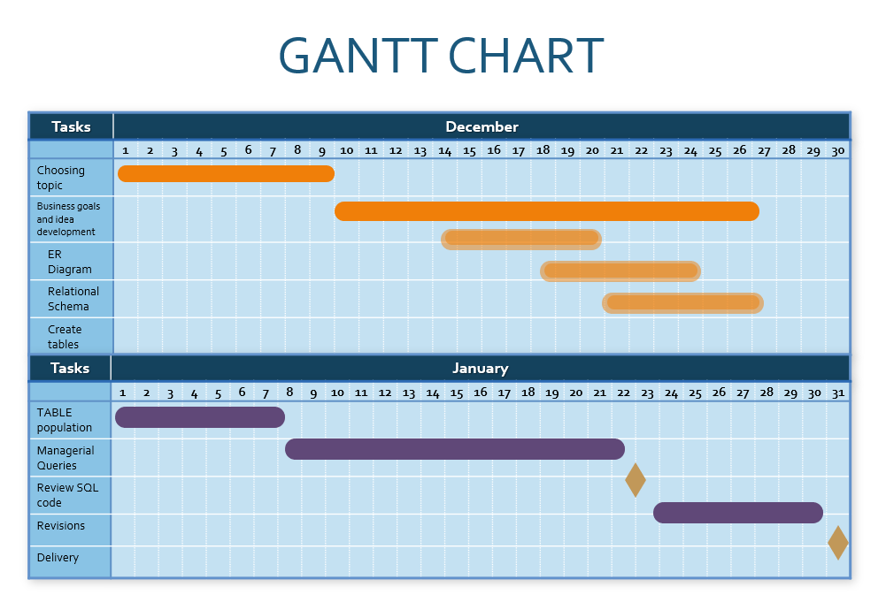

***The scope of the project***

The project is estimated to take about 2 months of work. Starting from December 1, 2021, spanning to January 31st 2022. Development time includes working on the business idea, the objectives and goals needed to be achieved. It also includes creating the ER Diagram, Relational Schema, tables in the SQL database, populating the tables, managerial queries and SQL statements to make sure the database functions correctly.

***The domain of the project***

The database will be a visual representation of the respective companies involved and the handling of them. This project covers the functional, contracted-company related, part of the system.

***Processes supported by the database***

* Separate its users in 2 categories: “admin” and “user”
  + **Admins** are able to create tasks, delete tasks, create users, edit task progress and assign “owners” to tasks.
  + **Users** can create tasks and view the tasks they are “owners” of or simply a part of.
* Companies initialize their first admin at the start of the work
  + The first admin can create other admins
  + The first admin can create users that are not admins
* Only **task owners** and **admins** can mark a task as finished.
* Task owners can browse through employees and add them to their own task.
  + Employees browsed are separated into employees already working on the task and employees available.
* For **all users**: id, username, email, password(encrypted) and user_type will be stored in the “users” table
* For **all tasks:** id, title, start_date, end_date, owner, submitted by, status, modified_at will be stored in the “tasks” table.

***Managerial Queries:***

The admin wants to know:  
The task title, owner, date_modified of tasks submitted by users in the company GREKKA.

The admin wants to know  
The user_id, username of all users that are owners of tasks for the TELLER company.

The admin wants to know  
The task_id, title, start_date, end_date, owner of all tasks that were started after a specific date.

The admin wants to know  
The task title. owners of tasks that have the modification date and end date with a difference bigger than 20 days.

The user wants to know  
The task_id, title of all tasks he is an owner of or a part of.

The owner wants to know  
The subsequent admins the original admin created for their company.

The admin wants to know  
The user_id, username of the top 5 employees with the most tasks.

The user wants to know  
The task title and managers of the TELLER company who are working on a task.

The admin wants to know  
The task_id, username of all tasks that have been modified in the present day.

The admin wants to know  
The user_id, username of all current employees that are currently not working on any tasks

***ER DIAGRAM***

The Entity Relationship Diagram represents the visual model of the project. The diagram shows all moving parts in the project as entities and shows the relationships between them. The main entities of the project are: COMPANY_CONTRACTED, TASKS, USERS, ADMIN.

Each of the entities contains one primary key.  
Each entity has two or more attributes  
There are 1:M and M:N relationships present in the diagram between different entities

**Entities and their attributes:**

Tasks entity - Attributes are: taskid(primary key), title, submitted_by, modified_at, start_date, end_date, owner  
taskid – keeps the ID for every task  
title – keeps the title for every task  
submitted_by – stores the name of the person who submitted the task  
modified_at – stores the time and date when the task was last modified  
start_date – stores the date when the task is supposed to start  
end_date – stores the date when the task is supposed to end  
owner – stores the name of the person who is named the owner of the task

Users entity – Attributes are: user_id, username, email, password, user_type  
user_id – keeps the ID for every user  
username – stores the name of every user  
email – stores the email address of every user  
password – stores the encrypted version of the password of the user  
user_type – stores the type of user

Admin entity – Attributes are: adminID, admin_name  
adminID – keeps the ID for the admin  
admin_name – stores the name of the admin

CompanyContracted entity – Attributes are: compType, compID, compCity  
compID – keeps the ID for every company contracted to the business  
compType – stores the type of company(the business they operate in)  
compCity – stores the loaction of the company

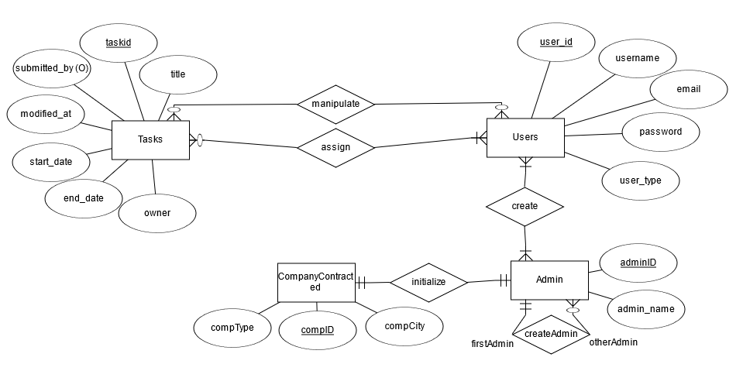

***Description of relationships***

Manipulate (M:N)  
A task can be manipulated by one or more users.  
A user can manipulate one or more tasks.

Assign(M:N)  
A user can assign one or more tasks to other users.  
A task must be assigned to one or more users.

Create(M:N)  
A user must be created by one or more admins  
An admin must create one or more users.

CreateAdmin(1:M)  
An existing admin can create other admins.  
Other admins must be created by the existing admin

Initialize(1:1)  
A company contracted must initialize the first admin of the project  
The first admin of the project must be initialized by the contracted company

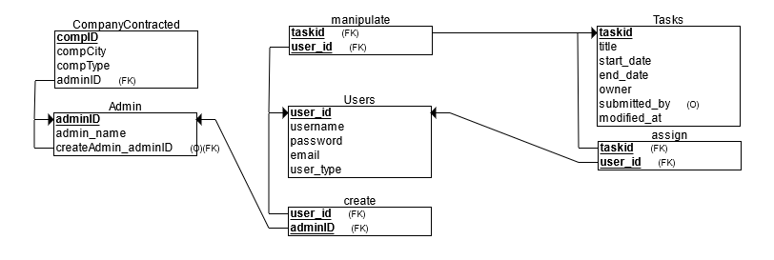***Relational Schema***

***Foreign Keys***CompanyContracted: adminID (Primary Key of Admin)  
Admin: createdAdmin_adminID (Primary Key of Admin) (Self referencing)  
Manipulate: taskID, user_id (Primary Key of Tasks)(Primary Key of Users)  
Create: user_id, adminID (Primary Key of Users)(Primary Key of Admin)  
Assign: taskID, user_id (Primary Key of Tasks)(Primary Key of Users)

***Conclusion***

In conclusion, I created a functional database that will aid in the procedures and workplace in all companies using the product. This will have a massive impact on the smoothness of operations and will accelerate all jobsite expansions or management which is crucial for a company’s success. The information is easy to access and the program is easy to use. Information will be stored without any duplication, allowing any company to work efficiently and process their data in a clean manner.